Here we are going to learn about Data Binding in Angular

1. **ONE WAY BINDING**

Bind data from typescript to html or from html to typescript

Bind data from component to template view or template view to component

Different type of one way binding

**A1. Interpolation (all of property / value will be considered as string)**

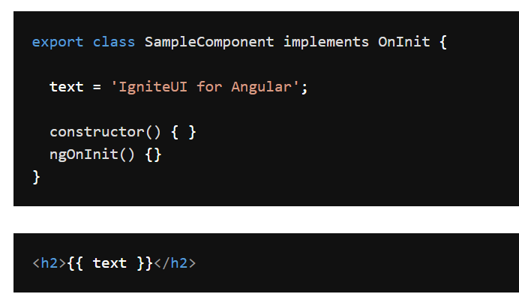

**A2. Property Binding**

Since interpolation only consider the value as a string, the question , how we able to bind value like boolean in case we have to disable a control for instance.

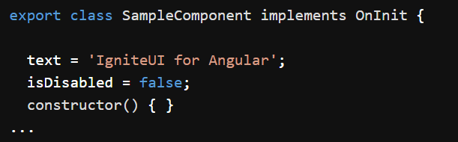



The script above doesn’t give an expected result, since isDisabled will be treated as string, therefore



**A3. Event Binding**

Here we will trigger property from view to component. For instance we able to use click event on button and so on



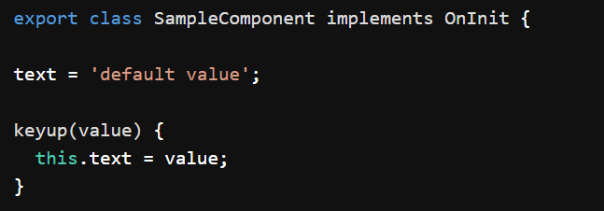

1. **TWO WAY BINDING**

Imagine this illustration.

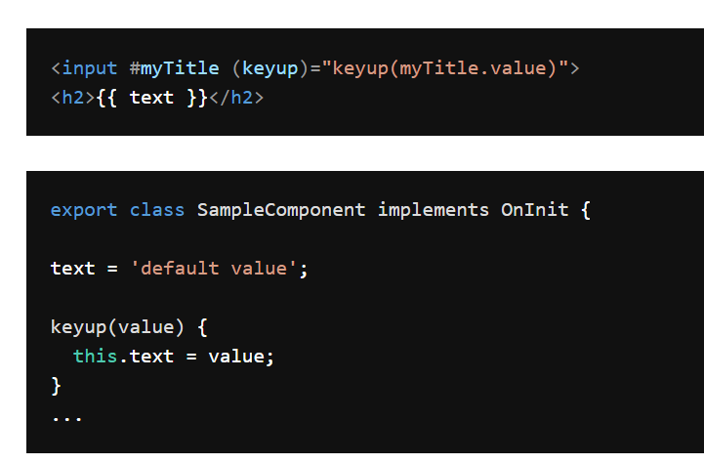

1. We will display a text variable / property in HTML = using interpolation (one way binding)
2. We need to update the text variable by key up event (one way binding)

- The initial result in “default value”

- Once user change the value (for example “change value)”, then it will trigger text variable value by event binding

- Finally the result that displayed into HTML is “change value”

In two way binding we only use

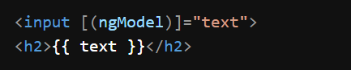

In input text the value will be changed,and also in h2 element

<https://www.infragistics.com/products/ignite-ui-angular/angular/components/general/wpf-to-angular-guide/two-way-binding>

<https://www.infragistics.com/products/ignite-ui-angular/angular/components/general/wpf-to-angular-guide/one-way-binding>